LEZIONE I
Applying data science techniques to biological and medical problems.
This lesson is going to talk about:
- Newborn Pain Assessment Regional project.
- Brain-Machine-Body connectivity – Horizon 202 project
- Synthetic data generation – Generative models for protein structure.
AUTOMATIC NEWBORN PAIN ASSESSMENT.
It started in 2017, it’s still going on, in collaboration with Mauriziano Hospital.
The general goal of this project is to develop an automatic system to assess pain in newborn (valutazione del dolore). This is system is contactless and NON-invasive.
- We are using a webcam to measure all the parameters necessary to estimate the pain of the baby.
- The system is working in an objective way.
- It is based on a continuous monitoring of pain and vital parameters.
The people working in this unit of the hospital asked for this tool because the traditional method was very subjective, depending on the sensibility of the operator. Consider that, going back to 80’s, it was the discover of the painful transmission mechanisms in newborn: the newborn is able to feel the pain and to remember it.
In 90’s, there was the validation of different algometric pain scales, so scales that allowed to quantify and give a score of the pain.
Since 2010 in Italy, pain must be written in the medical records as one of the vital parameters.
Despite this, now only a very few professional operator used pain scales to assess newborn pain. Because they include many parameters, and it depends a lot on the experience of the operator.
NEONATAL PAIN SCALES.
- DAN: Douleur Aigue du Nouveau-nè (1996). Consideres facial expression, the limb movement and the vocal expressions of the baby. The operator observers the baby, if he is calm, eyes squeezes, nasolabial furrow, how the face of the baby is, if he is crying, they give a score ( out of 10).
NFCS: Neonatal Facial Coding System (1987). It considers ONLY facial expressions, you see particular positions of the tongue (taut tongue), open lips, if the mouth is stretched horizontally or vertically. Here you have a score out of 9.
- PIPP: Premature Infant Pain Profile (1996). It considers the behavioural state: if he is active, quiet, awake, sleep. It considers also the physiological parameters of the baby, and the facial expression.
The facial expression are very common to all the scales, so the project started from them. The expression is very correlated with the feeling of the baby.
FIRST APPROACH: THE FACIAL EXPRESSION.
There was the acquisition of 15 videos that were analysed. For example, during the hell-sick procedure for the acquisition of blood, the baby starts crying, so we can deduce that is a painful operation.

It’s requested:
- Written informed consent from the parents
- Study protocol approved by the Local Ethic Committee.
INITIAL WORKFLOW.
3 tecniques to analyse parameters.
- Landmark: landmark tracking. It’s very precise thanks to AI too.
- Edge: face furrowing detection
- Greyscale: binary thresholding.
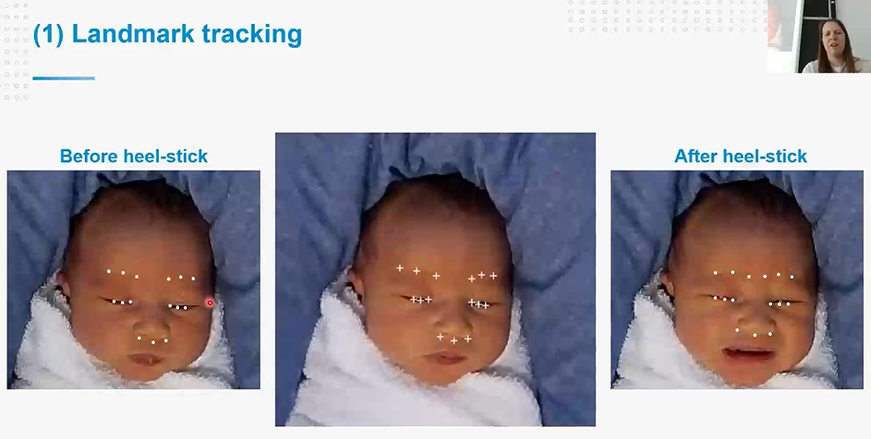
The landmark change positions when the baby is starting feeling the pain.
The idea is to use this landmark to track the segment and calculate the distance that the landmark has over time.
This system was working NOT in real time but OFF-LINE. You could see the signal representing the evolving over the time. Now we are working in real time.
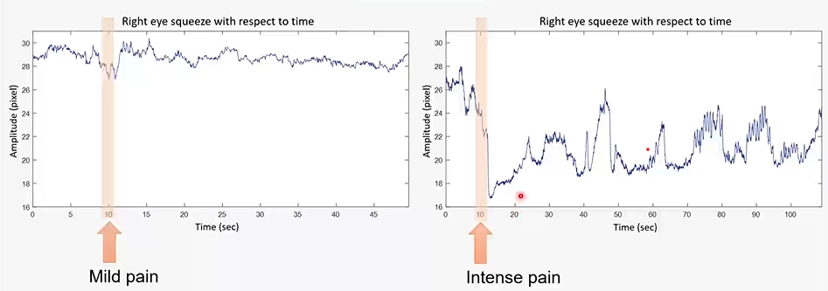
For MILD PAIN, we have a little distance between points, the opposite for INTENSE PAIN.
It is measured based on the number of pixels.
The EDGE ANALYSIS it was used to calculate:
- Brow bulge (Sporgenza delle arcate sopraccigliari)
- Deeping of nasolabial furrow (Approfondimento del solco naso-labiale).
GRAYSVALE ANALYSIS.
It is based on the vertical and horizontal stretch of the mouth. You observe for how much time the mouth is open. You can find a way to code the parameter of the tongue bending (arricciare la lingua), and you can also see if there is the intermittent/continuous weeping of the baby (pianto). All of these parameters extraction is use to calculate the score with the pain scales that we saw before.
For example, for the DAN pain scale, regarding the facial expression they give a score out of 4.
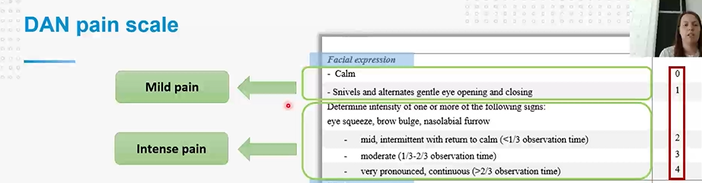
You can see that we have eye squeeze, brow budge (inarcare sopracciglia), nasolabial furrow, that are the parameters that we calculate before.
The NFCS scale uses the presence/absence of all the parameters.
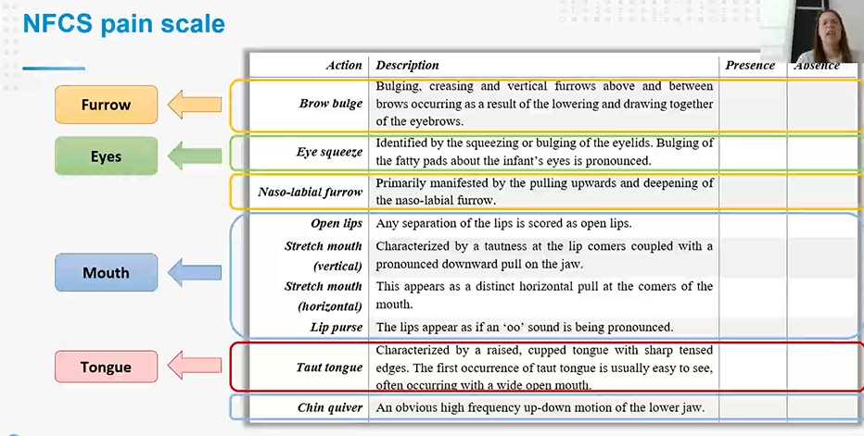

The PIPP scale considers the PHYSIOLOGICAL PARAMETERS too.

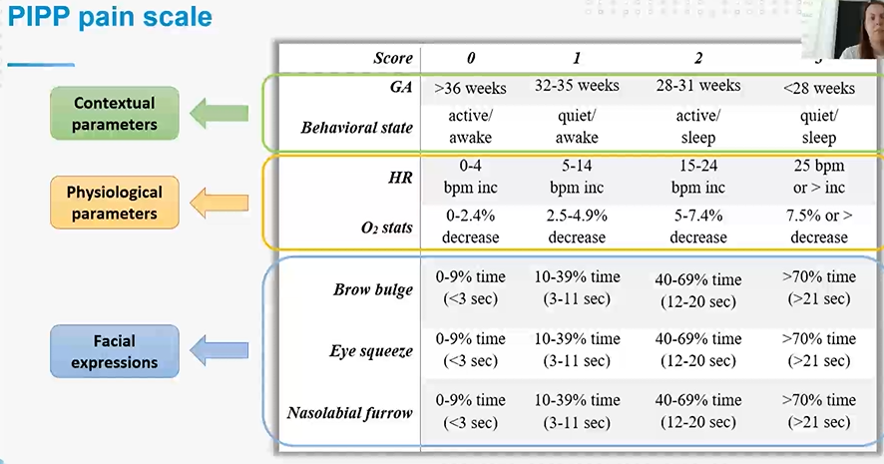
The instruments for the physiological parameters are not contactless now. We are trying to focus on heart rate instead of Oxygens saturation by video recording only.
During the experimental results, the idea was to compare the results obtained from automated analysis to the manually assigned scores with three different metrics:
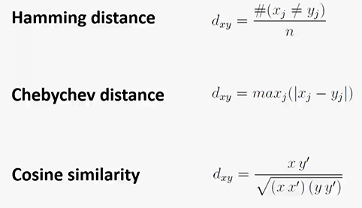
Many interesting things came out.
For example, we had three operators. Each of one different scores in a subjective way, resulting in a mis-match among the operators themselves. It happened for NFCS and PIPP scales too.
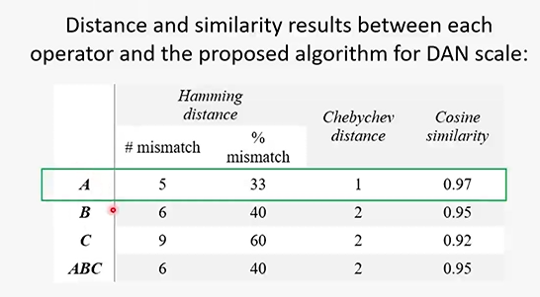
From results, we observed that eyes squeeze reported less mismatch, because it was easier to calculate, instead of the lips purse (difficult to calculate with precision).
The newborn pain assessment is a problem that highly depend on:
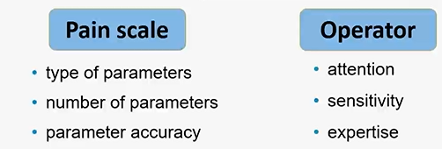
The people were asking for a objective system to quantify the pain in an objective way, measuring all the parameters together.
The actual challenge is to obtain:
- real-time pain assessment system
-not only the pain but vital parameters (heart rate, oxygen saturation, respiration rate).
- pose estimation (tool like OpenPose, based on multistage CNN, is a neural network and an open access tool for pose estimation, called “MediaPipe”. It uses points to improve the facial parameters detection).
/ -------------------------------------------------------- /

PART II. B-CRATOS

Wireless brain-connect interface to Machines.
This is an european project among Horizon2020 FET OPEN.
FET: future and emerging technologies.
FET OPEN: supporting scientific research at the very initial phase of the development of radically new technologies.
For the first time we have a battery-free high-speed wireless in body communication platform for Brain-Machine-Body connectivity. This project tries to ask to a challenge: “amputees tend to abandon their prosthetic extremises as they are not integrated to the person’s cognition”. B-CRATOS wants to better integrate the prosthetic extremities.
It starts from reading the signal coming from the brain, then transmit them to a particular wireless communication using the subdermal fat, and bringing the signal to control the prosthetic extremities and, at the same time, give a feedback to the brain using sensors placed on the prosthetic extremities themselves, reporting the sensation to the brain.

BCI.
BCI: Brain Computer Interface. A device that enables communication and control without movement. A system that is capable of the reading and then elaborate them through an algorithm and return feedback back to the brain.
CLOSING THE LOOP: providing feedback to the brain, can be done in different ways (electrical current, magnetic field, chemical).
We focus on electrical stimuli, which reproduce the tactical sensation through the robotic arm.
We need this because there is a gap in treating neurological aliments.
There are many researches about BCI regarding other fields, like:
- MOOD REGULATION
- MEMORY IMPROVEMENT.
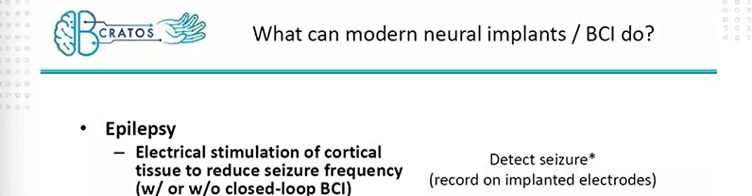
All the existing system have limitation.
- The first challenge is in the channel count and signal bandwidth. The system have few channel, so they record the signal from the brain from few location and the signal is not so rich. Modern algorithms for electronic arm need rich signal to perform all the possible movement.
- PROCESSING POWER: we can move the processing of the signal outside IN SOME external device.
- WIRES, PHYSICAL SIZE. The presence of wires it is not ecstatically nice, there is the infection risk.
- BATTERY: if you have an implanted system in your brain, a battery failure could be rally. dangerous.
The idea of the project is to develop a new proof of concept brain implant device HIGH CHANNEL, Battery less, Wireless data transfer, compact, hermetically-sealed design for subcutaneous implantation on the skull.
B-CRATOS will link this implant device to external prosthetics and computational modules for decoding and stimulation control: in body microwave propagation technique through subdermal body fat (Fat-IBC).
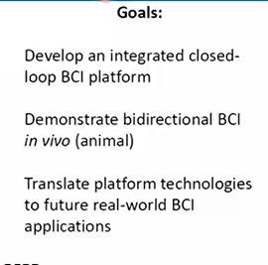
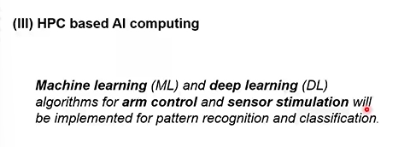

LINKS Module.
The idea is moving the processing out, in an external board, using machine/deep learning models, first to decode thee signal coming from the brain, stand the right command to the robotic arm and then take tactile from the sensorized skin and use it to find the right electrical stimulation to give to the brain.
This board should also communicate with HPC infrastructure to perform the training phase.
Machine Learning activity: Grasp classification.
The signals that are required from the brains are like train of spikes. We can detect which kind of grasps correspond to these signalas Recordings are annotated with experiment phase. For now they have studied how to detect if there is grasp or not, and which kind of grasp do we use to take an object for example.
These data comes from an implanted tool in monkeys (experiment). It’s very difficult to have the training session. It’s not easy to train e valuate a model in a supervise way.

For example, there is difference between the signal coming from one monkey and another, like in the image.
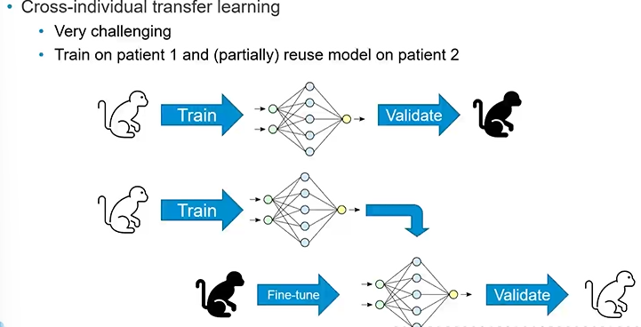

Obviously the idea is to implant the system on humans.
Other challenges are:
- Optimization and deployment of ML model on low-power devices
- Closed-loop BCI, upstream channel: Modelling of stimulations signal based on inputs from sensorized skin. We have to understand how the implanted system works.

PART III
GENERATIVE MODLES FOR PROTEIN STRUCTURE.

Comparison between Generative Adversarial and Autoregressive networks.
GOAL of the research: starting from a dataset of a protein family, learn to generate new protein sequences that are statistically indistinguishable from the ones in the same family.
The application of this work is to reach a synthetic generation of new protein sequences, in order to exploring the space of possible amino acid configurations.
Generative models: can learn the input data distribution and generate new samples.
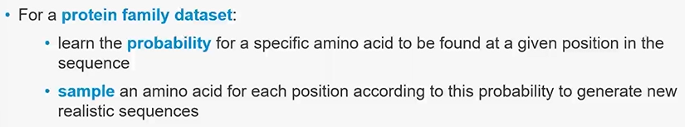
GANs: Generative Adversarial Networks
AR: Autoregressive Neural Networks.
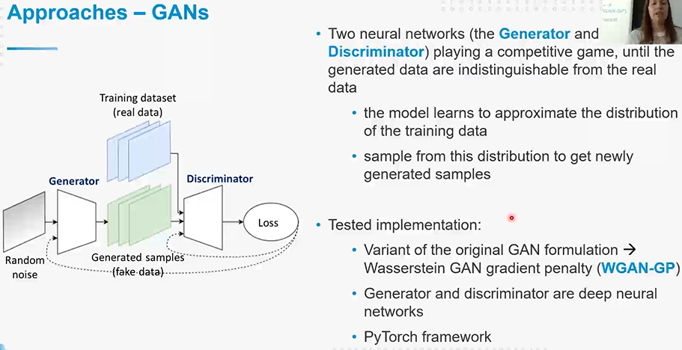
The generator has the aim to generate fake data sample indistinguishable from the real data in the training set. Discriminator: learn to correctly distinguish the real data from the fake. The play this competitive game until the generated data are indistinguishable from the real data, because the two networks keep improving their abilities. In the end, the model learns to approximate the distribution of the training data.
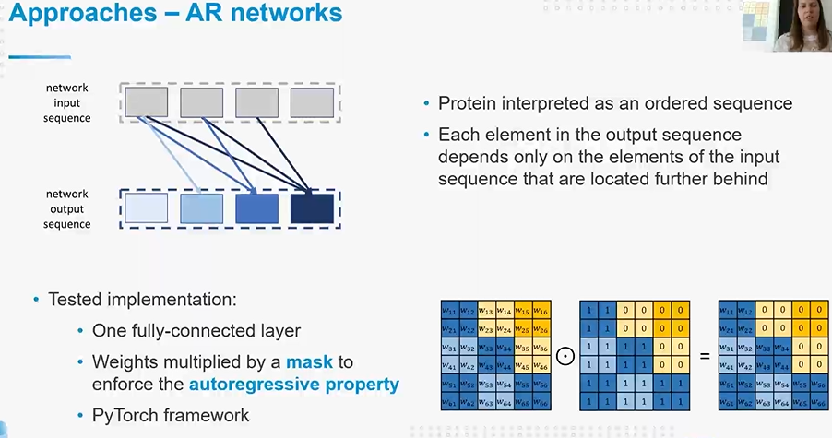
Using AR, you interpreter a protein as a order sequence. Each element in output sequence depends on the element of the input element located further behind. The test implementation was simple, thanks to one fully connected layer.
As dataset, we use Multiple Sequence Alignment (MSA). That can be interpreted as matrices of size.
N: number of sequences. L = number of positions. Q = number of symbols ( 20 amino acids + gap symbol).
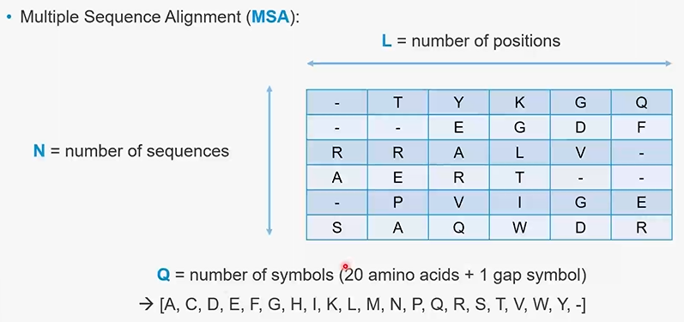
Ones you have used this generative model to generate new protein, then you actually have new sequences alignments.
How can you evaluate if this protein make sense or have or not a good quality?.
FIRST METHOD: CORRELATION PLOTS. Check correlation between the empirical frequency counts of the amino acids.
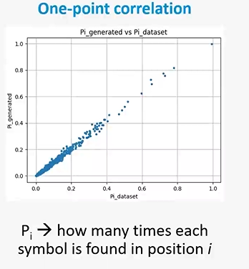
Frequency count: P_{i}. How many time each symbol is found in position _{i}.

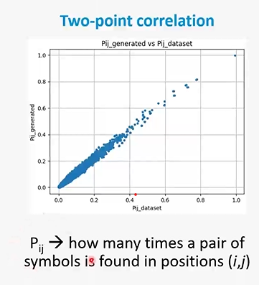
P_{ij} . How many times a pair of symbols is found in positions (I, J).

SECOND METHOD: SENSITIVITY PLOTS. It uses direct coupling analysis (DCA) to check similarity in the three-dimensional structure.
DCA is like a method used to predict contacts in multiple sequences alignment.
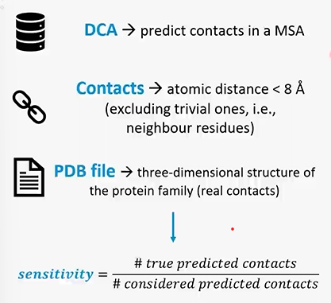
You consider only the residue at a small distance without the trivial ones that are the neighbours.
You can find the real contacts in this PDB files, containing the three-dimensional structures of the protein family.
DSA does only a prediction of contacts. It’s not everything certain.

Both the approaches are capable of generating protein sequences that are statistically similar to the ones in the original dataset of their family.
Models automatically get insight about the three-dimensional folded structure.

